Documentation On

**Online Training Management System**

For JEE Parallel Project

By:

Bandaru Tejaswini(Emp Id:46002256)

**Table Of Contents**

1. Abstract
2. Scope
3. Diagrams
4. Class Description

**Abstract**

Online Training Management System is designed for the employees to learn from online training programs. This project is aimed at developing a web application, accessible form any device(desktop or mobile), from anywhere across the world. This system is driven by two entities, admin and employee. This system enables employees select the courses from various categories, register for the course, bookmark the chapters in a specific course, view all his/her registered courses and track his/her progress in the course. The admin can add a course, add chapters to the course, add video to the chapter, modify the course by adding, modifying and deleting chapter, delete the course and view statistics of all courses.

**Scope**

**Admin**

1. Add Course

2. Modify Course

1. Add Chapter

* Add video

1. Modify Chapter

* Add video
* Delete video

1. Delete Chapter
2. Delete Course
3. View All Courses
4. View Statistics of All Courses

**User**

1. Register Course
2. Select courses from different categories
3. View all registered courses
4. Bookmark chapter in a specific course
5. Track course progress

**Out Of Scope**

1. Company or educational login
2. Tests provided for any course.
3. Q&A
4. Download Course
5. Chapter with multiple videos
6. Subtitles for the videos
7. Payment for the course

**Diagrams**

**Sequence Diagram**

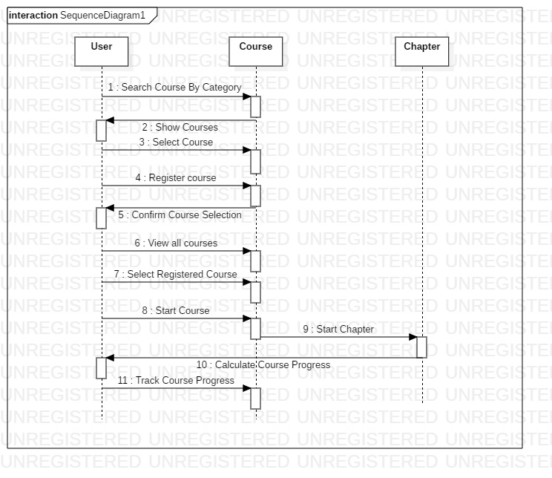

**Class Diagram**

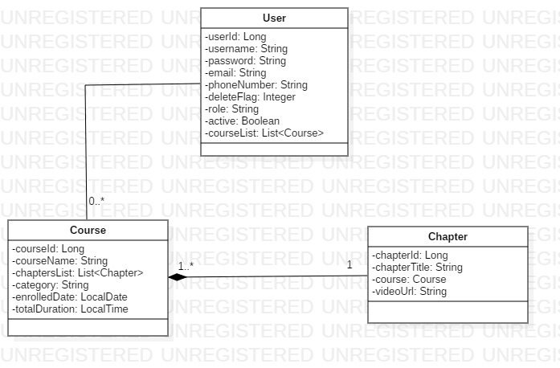

**Activity Diagram-Admin**

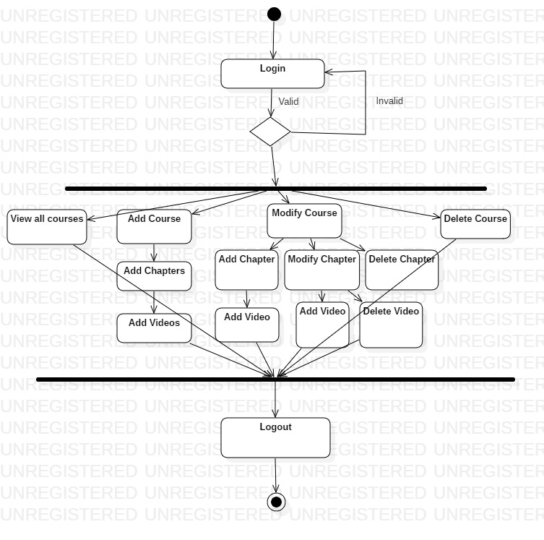**Activity Diagram-User**

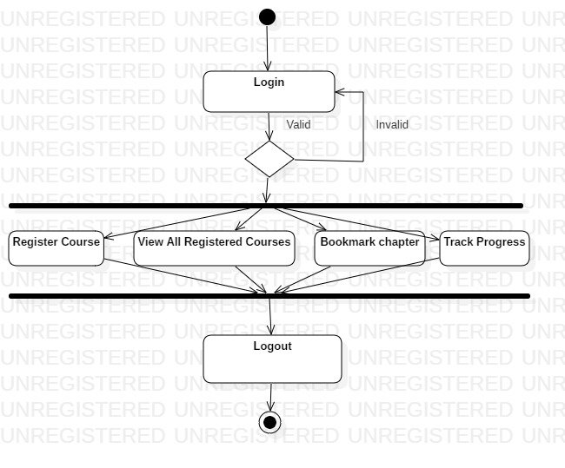

**E-R Diagram**

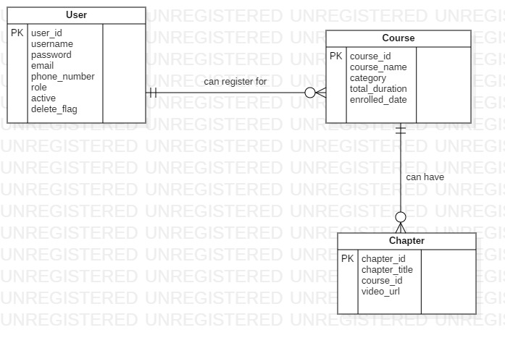

**Use Case Diagram-Admin**

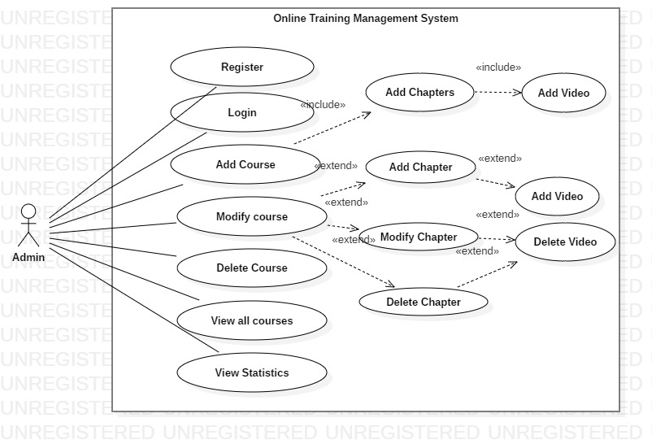

**Use Case Diagram-User**

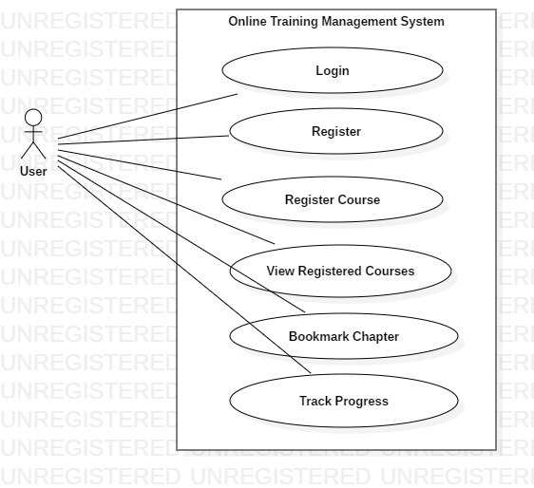

**Service Diagram**

**Wireframes**

**Class Description**

The following are the classes used in the Online Training Management System:-

1. **User**:-

* Attributes:-
* userId: Long
* username: String
* password: String
* email: String
* phoneNumber: String
* deleteFlag: Integer
* role:String
* active:Boolean
* courseList:List<Course>
* Methods:-
* viewCourses():List<Course>-lists all the courses
* viewCoursesByCategory():List<Course>-lists all the courses based on the selected category
* registerCourse():Course- register the course for a user
* viewRegisteredCourses():List<Course>-view courses registered by the user
* bookmarkChapter():Integer-sets the bookmarkFlag to 1
* trackProgress():Double-updates the progress of the user and returns the updated value.
* addCourse():Course-Adds the course to the course list
* addChapter():Chapter-Adds the chapter for the selected course
* modifyChapter():Chapter- Add video or delete video from the chapter
* deleteChapter():Integer-Sets deleteFlag to 1 on deleting the chapter.
* deleteCourse():Integer-Sets deleteFlag to 1 on deleting the course.
* viewStatistics():Map<String,Integer>-Lists the count for each course visited.
* Login():User-logs in to the website if the user details already exists
* Register():-User registers if new to the website
* Constraints:-
* login():-

1. Username and password should not be null or empty.
2. Username should contain only alphabetical characters
3. Password should match with username, else throws “Invalid Credentials”

* register():-

1. Username should not be empty and contains only alphanumeric characters.(A-Za-z0-9).
2. Password should not be empty and contains at least one uppercase, one lowercase, one digit and one special character. Should be of minimum 8 characters
3. Phone Number should contain only 10 digits
4. Role of the user should be selected.

* addCourse():-

1. Course name should contain alphanumeric characters and should not be empty.
2. Category for the course should be selected from the menu.
3. Enrolled date should be the date in the future.
4. Course name should be unique.

* registerCourse():-

1. Disable the “register” button if the course is already registered.

* addChapter():-

1. Add to the course which is already existing
2. The video uploaded should be only in the format “*.mp4”.
3. Chapter title should contain only alphanumeric characters.
4. **Course**:-

* Attributes:-
* coursed:Long
* courseName:String
* category: String
* chapterList:List<Chapter>
* totalDuration:LocalTime
* enrolledDate:LocalDate
* registerFlag:Integer
* deleteFlag:Integer

1. **Chapter** :-

* Attributes:-
* chapterId:Long
* chapterTitle:String
* videoUrl:String
* course:Course
* deleteFlag:Integer